Create a nexus-SG with port number open , 22,80,443,8081,8085
create an instance with t3.medium/t2.small
#Install java 1.8
sudo yum install java-1.8.0-openjdk.x86_64 -y
or
cd /opt
wget wget -c --header "Cookie: oraclelicense=accept-securebackup-cookie" http://download.oracle.com/otn-pub/java/jdk/8u131-b11/d54c1d3a095b4ff2b6607d096fa80163/jdk-8u131-linux-x64.tar.gz
tar -zxvf jdk-8u131-linux-x64.tar.gz

ls -ltr
ls -ltr
cd /opt/jdk1.8.0_131
pwd
alternatives --install /usr/bin/java java /opt/jdk1.8.0_131/bin/java 2
alternatives --config java
alternatives --install /usr/bin/jar jar /opt/jdk1.8.0_131/bin/jar 2
alternatives --install /usr/bin/javac javac /opt/jdk1.8.0_131/bin/javac 2
alternatives --set jar /opt/jdk1.8.0_131/bin/jar
alternatives --set javac /opt/jdk1.8.0_131/bin/javac

java -version
javac -version

cd
echo "export JAVA_HOME=/opt/jdk1.8.0_131" >> .bash_profile
echo "export JRE_HOME=/opt/jdk1.8.0_131/jre" >> .bash_profile
echo "export PATH=$PATH:/opt/jdk1.8.0_131/bin:/opt/jdk1.8.0_131/jre/bin" >> .bash_profile

source ~/.bash_profile
echo $JAVA_HOME

#Download nexus, extract it and renamed to nexus-3.45
cd /opt
wget https://download.sonatype.com/nexus/3/nexus-3.45.0-01-unix.tar.gz
tar -zxvf nexus-3.45.0-01-unix.tar.gz
mv /opt/nexus-3.45.0-01 /opt/nexus-3.45
ls -ltr
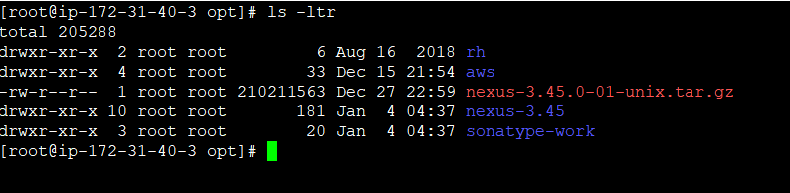

#Add the user nexus and give root privilege
useradd nexus
visudo
nexus ALL=(ALL) NOPASSWD: ALL
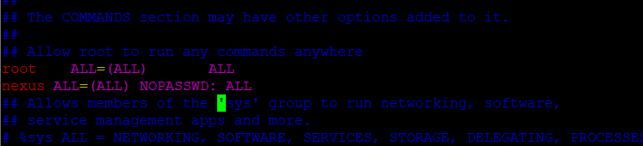
id nexus

#Change the ownership and permissions recursively for the directories nexus-3.45 and sonatype-work
chown -R nexus:nexus /opt/nexus-3.45
chown -R nexus:nexus /opt/sonatype-work
chmod -R 775 /opt/nexus-3.45
chmod -R 775 /opt/sonatype-work
ls -ltr
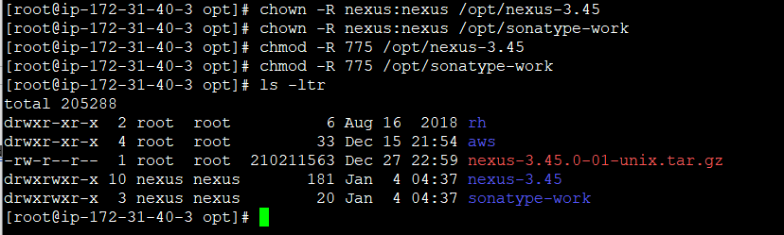
#open /opt/nexus-3.45/bin/nexus.rc fine and uncomment run_as_user
vi /opt/nexus-3.45/bin/nexus.rc
run_as_user="nexus"
:wq!

create nexus as a service (to run the application as nexus user)
ln -s /opt/nexus-3.45/bin/nexus /etc/init.d/nexus
su - nexus
whoami
sudo systemctl enable nexus
sudo systemctl start nexus
sudo systemctl status nexus
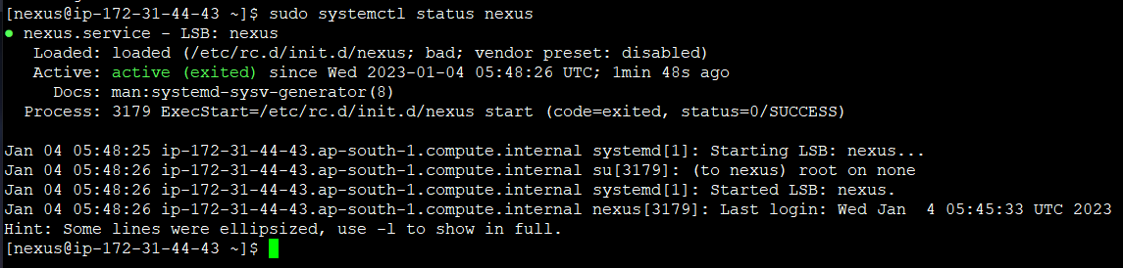

Go to browser and type publicip:8081
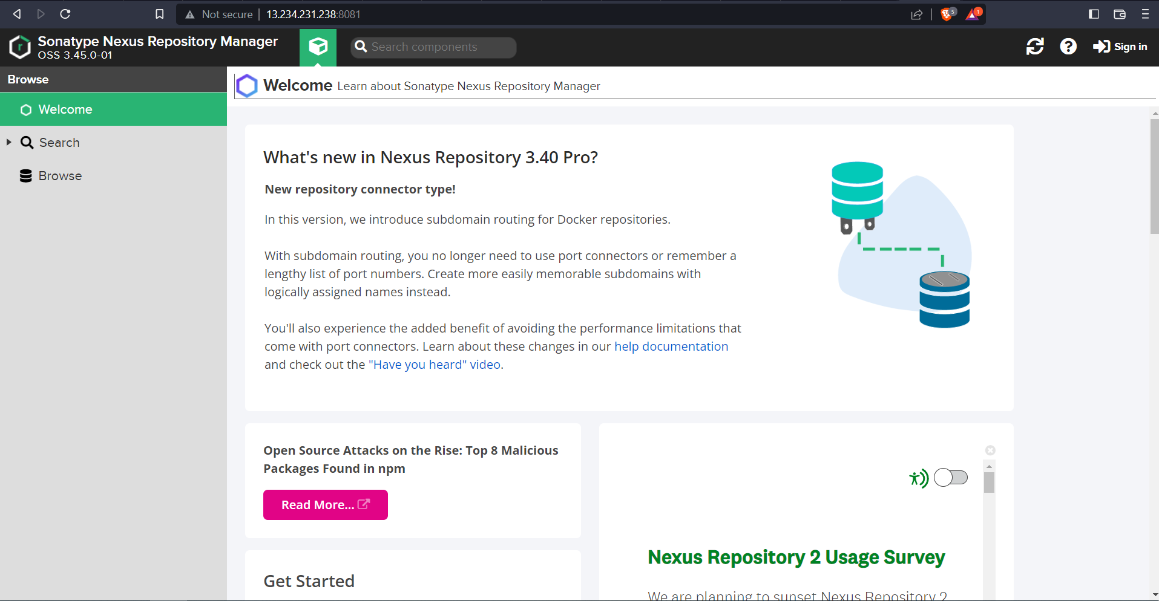
Click on Sign in
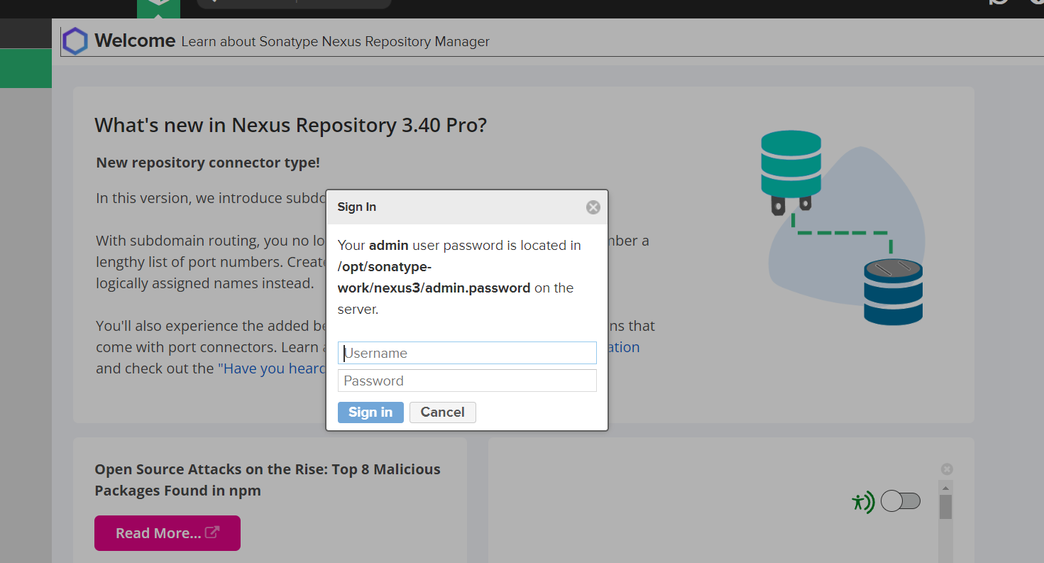
Go to instance to get the password
cat /opt/sonatype-work/nexus3/admin.password
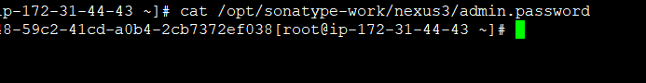

Type the username and password and login
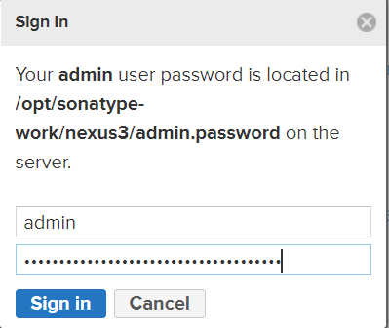
Click on next and give new password
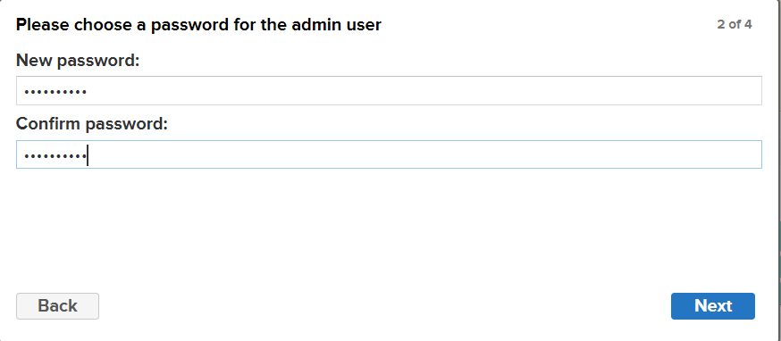
Click on enable anonymous access
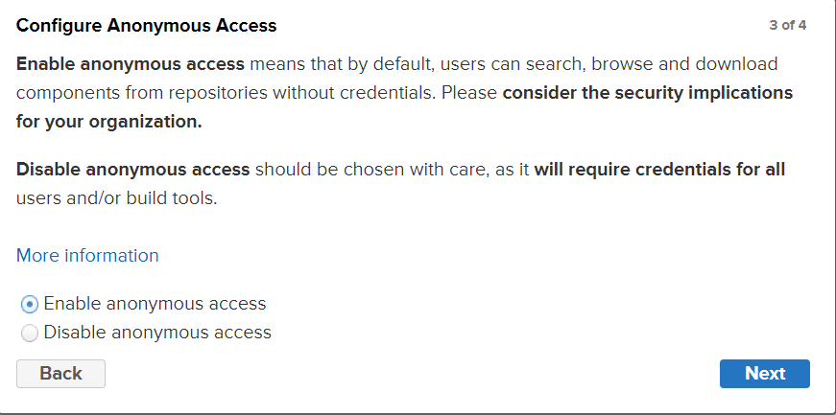
Then click on next and finish.
Nexus is normally integrated with LDAP servers so we can add the roles in nexus and assign to the users.
Go to server administration and configuration and click on the roles
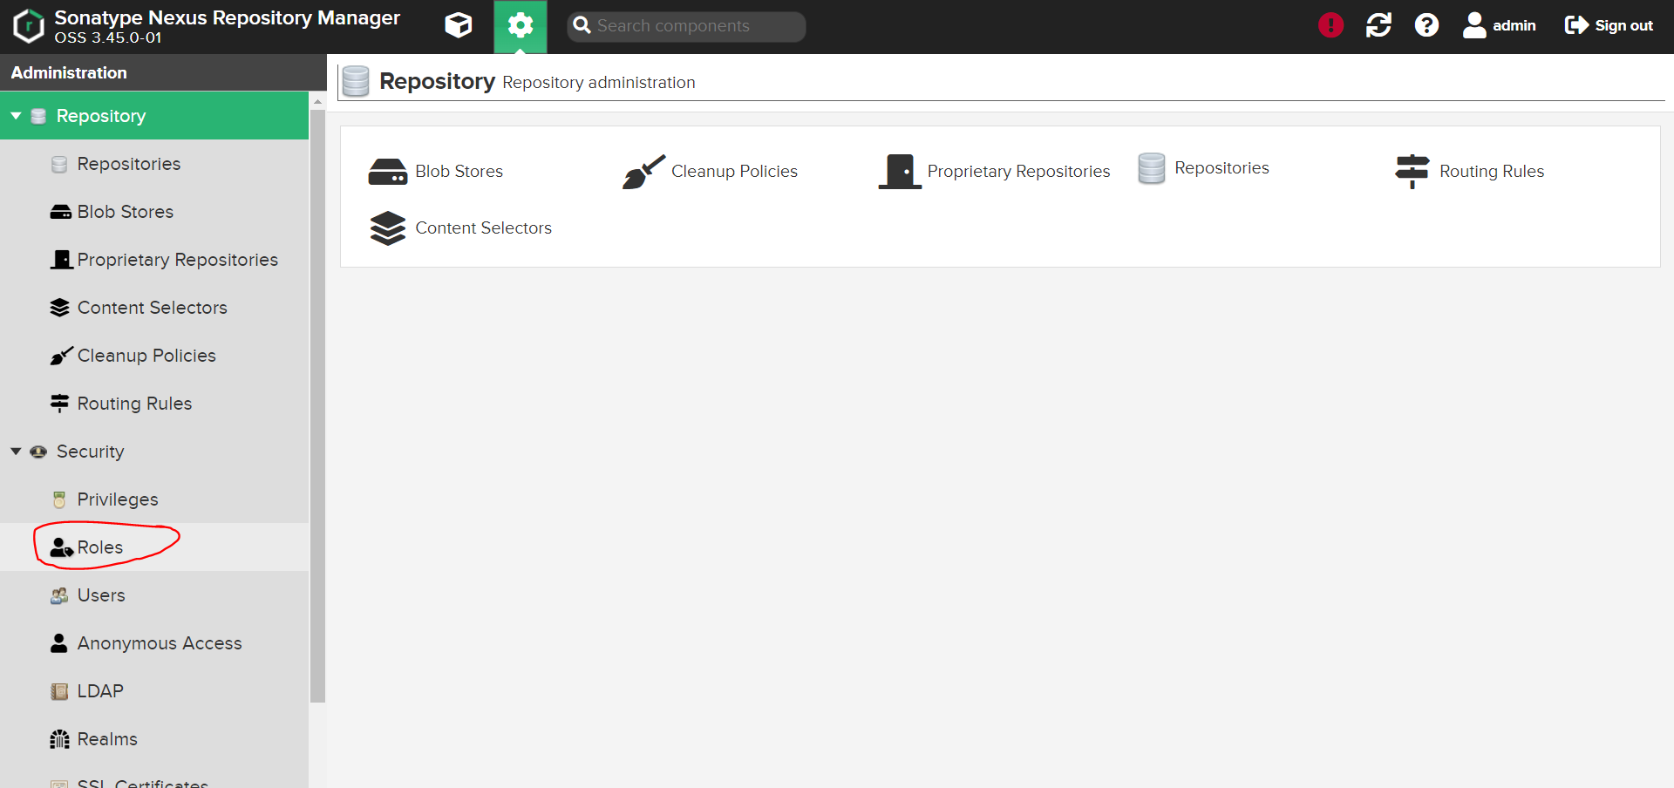
Click on create a role
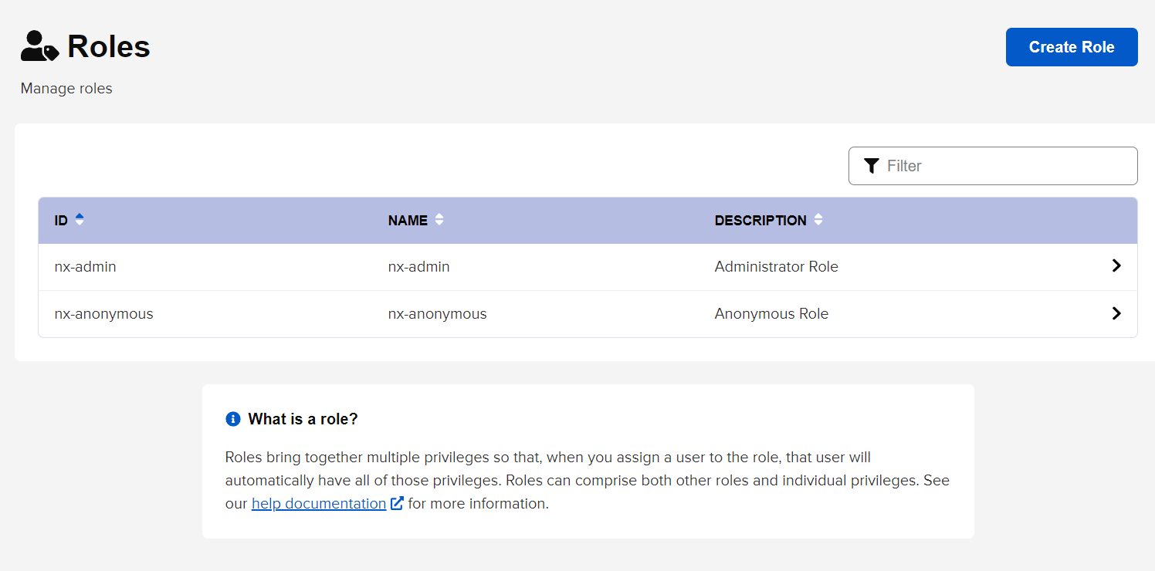

Add a role for an example. Give some docker privileges and click on save to create the role.
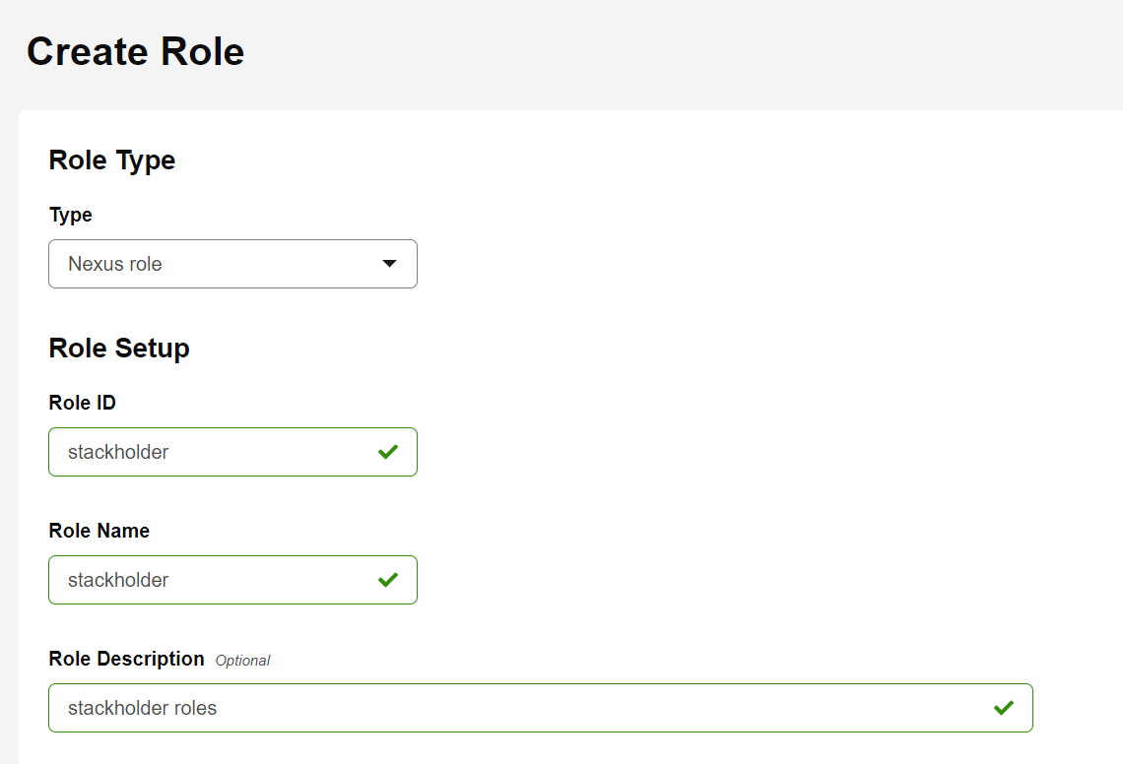
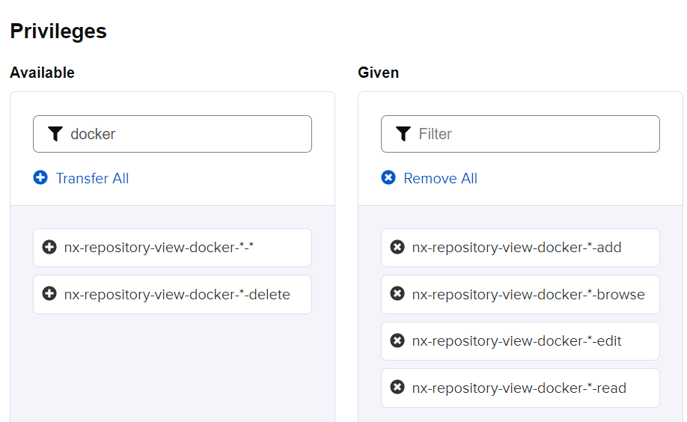


Now you can see the role has been added
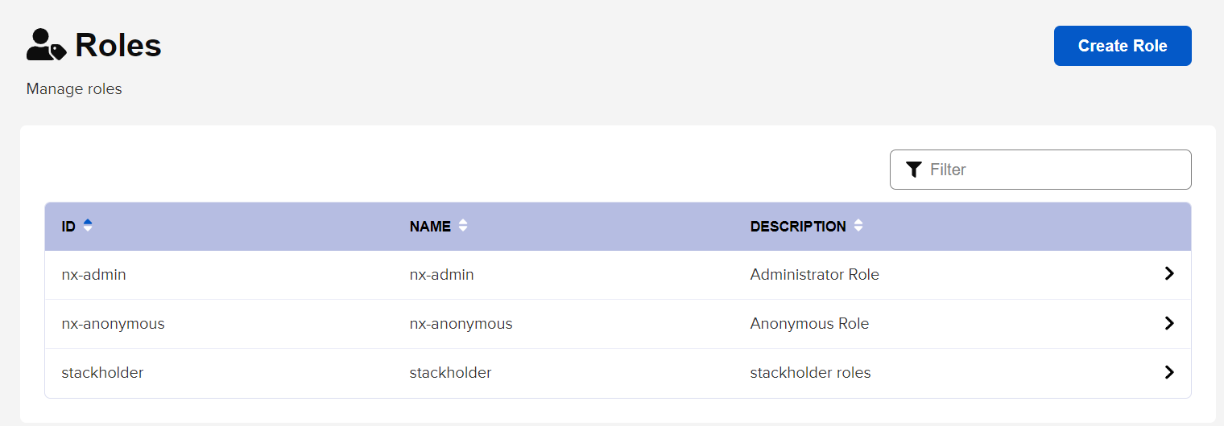
If we are integrated with LDAP server, we can add the LDAP connection ad add the roles to users
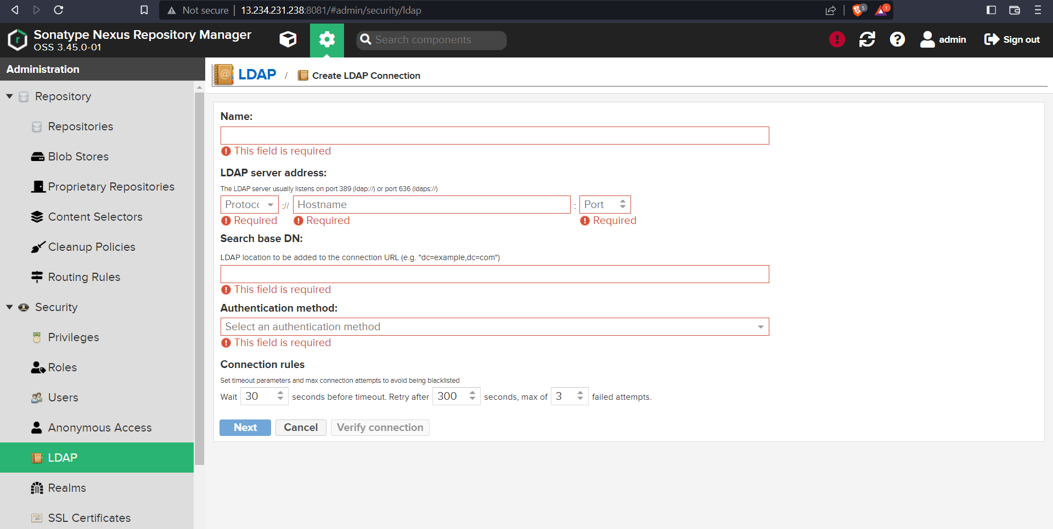
Currently we are not using LDAP server.

Go to AWS S3 and click on create bucket
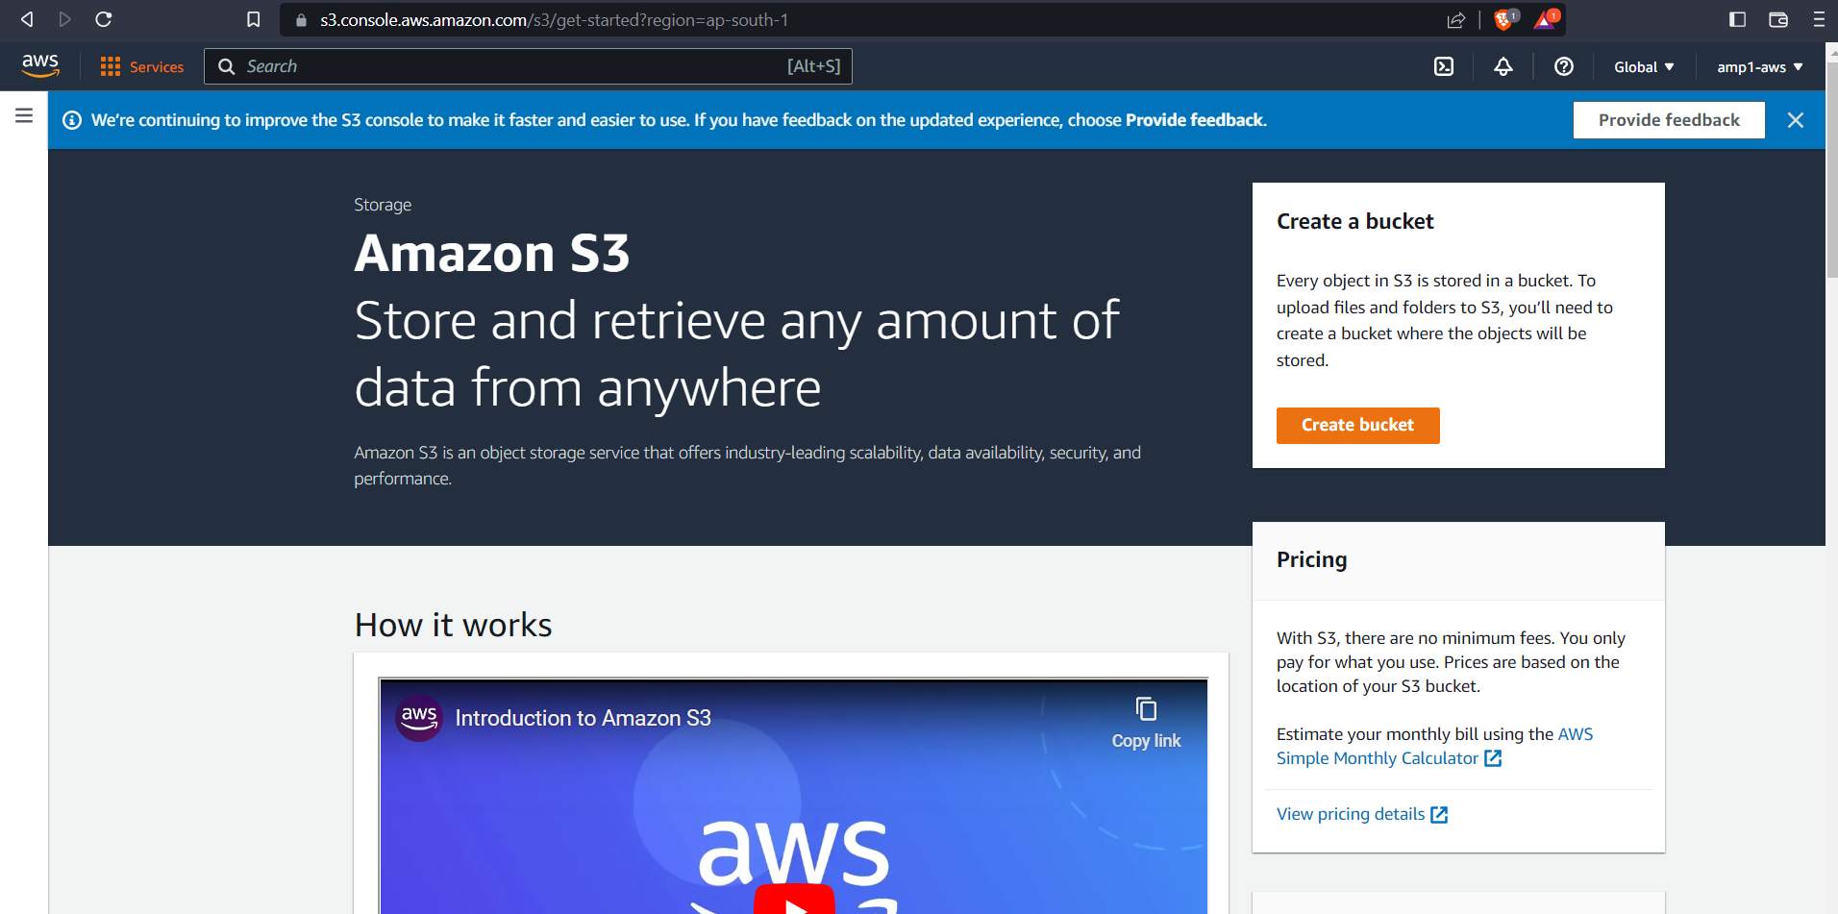

Enter the Bucket name, Region, and select ACL enabled
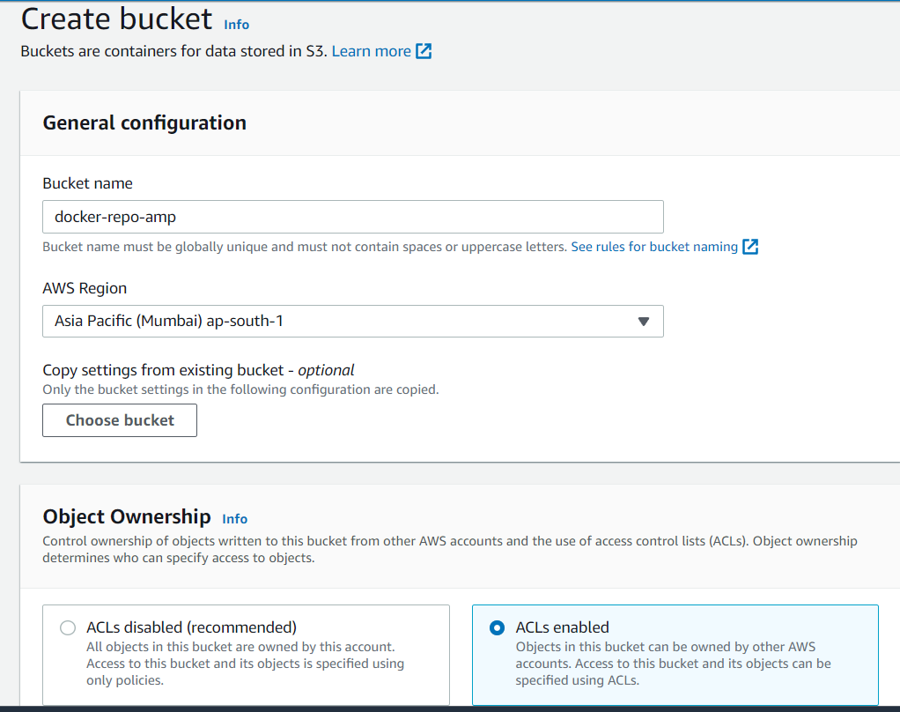
Untick block all public access and tick on I acknowledge that the current settings might result in this bucket and the objects within becoming public.
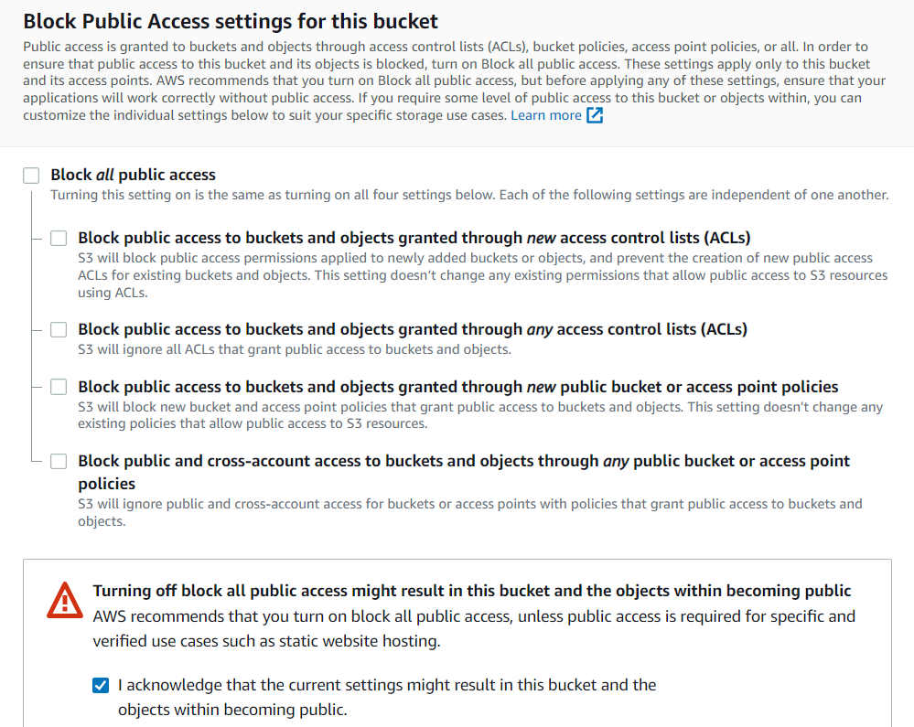
Select bucket versioning enable
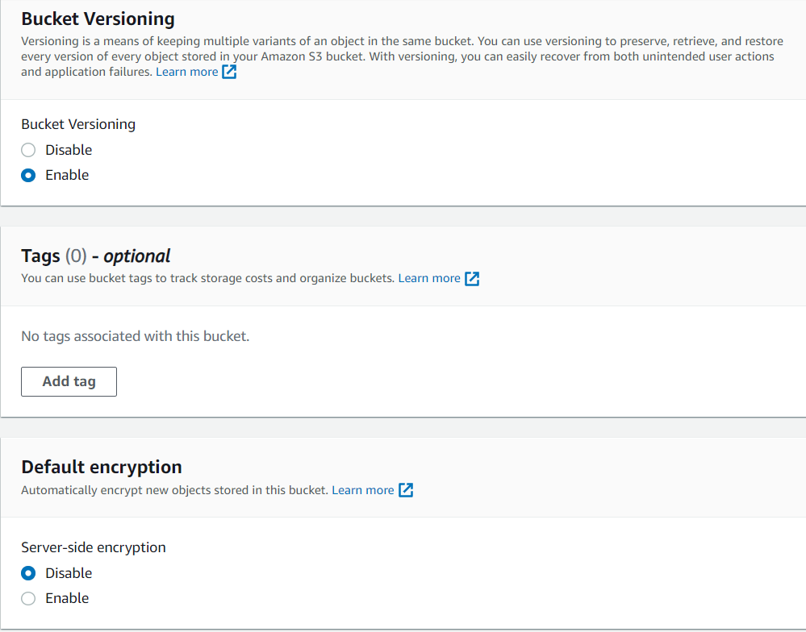
Then click on create bucket.
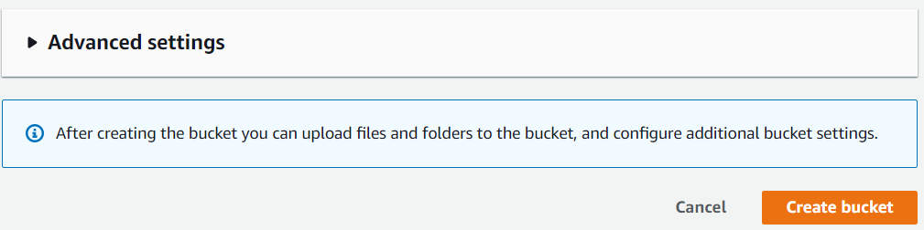
Now you can see the S3 bucket has been created
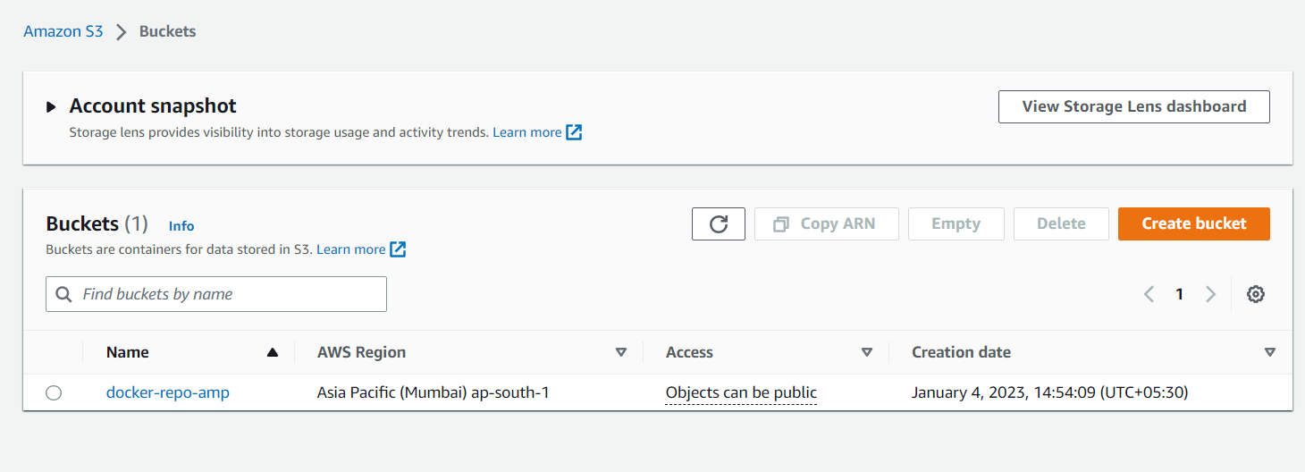
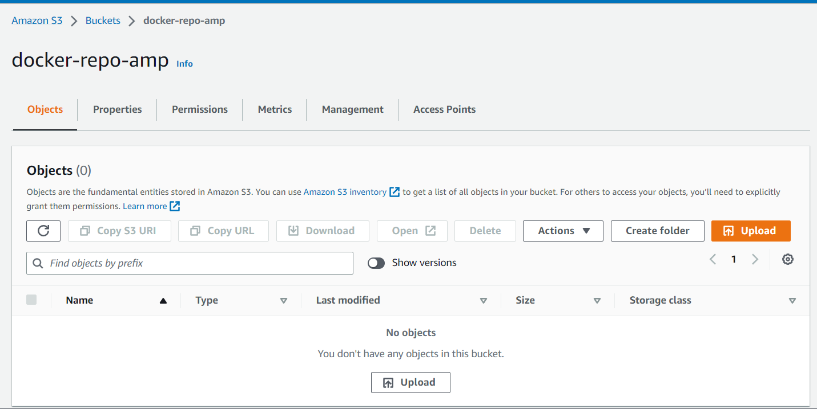
Go to nexus and click on blob stores
Click on create blob store
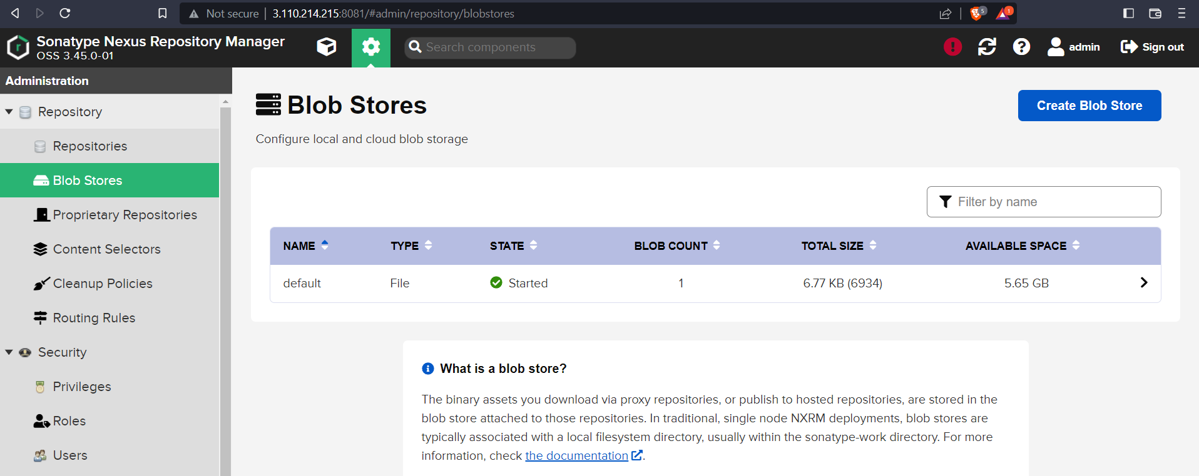
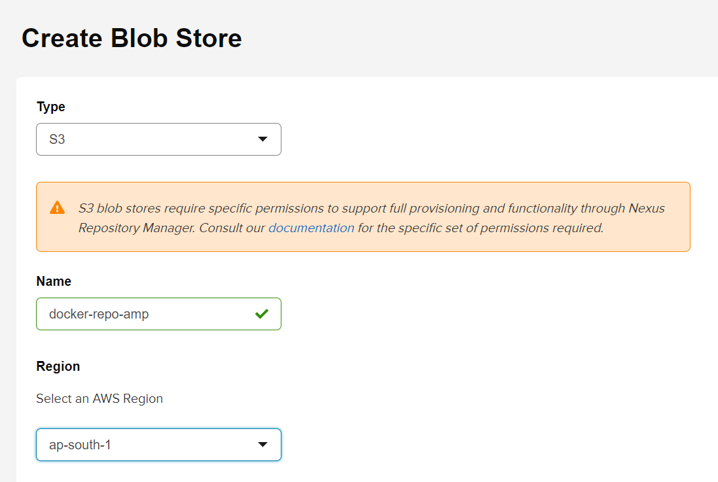
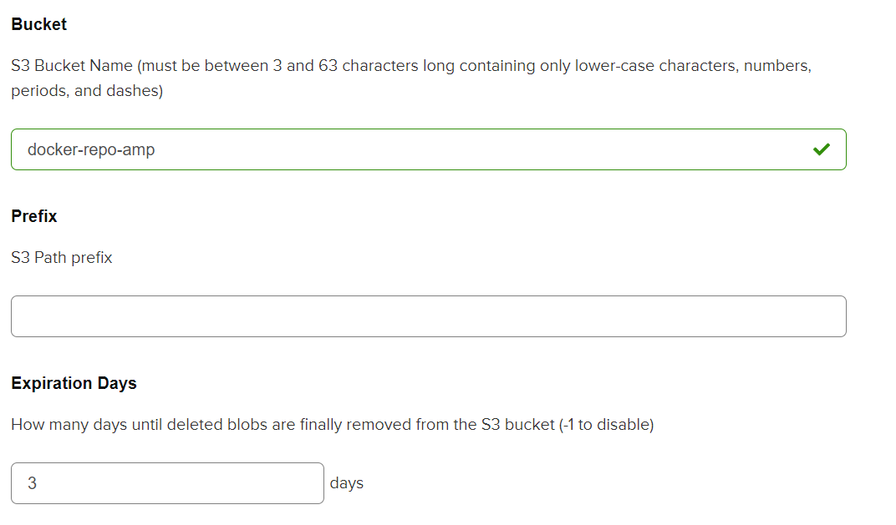

Go to AWS IAM and create a new user with amazonS3fullaccess
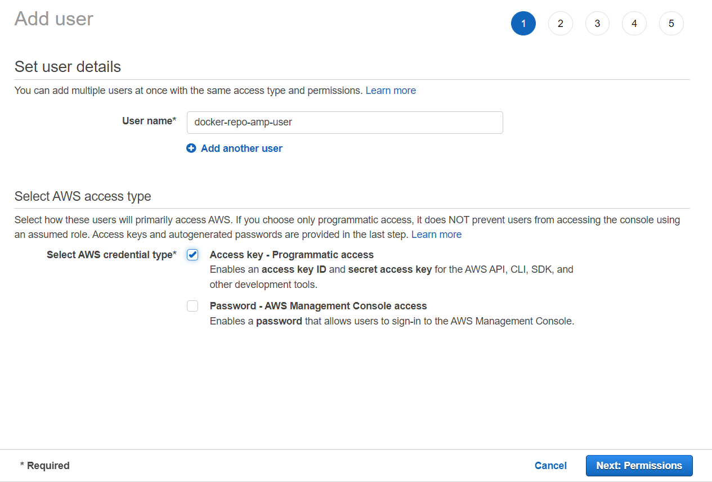
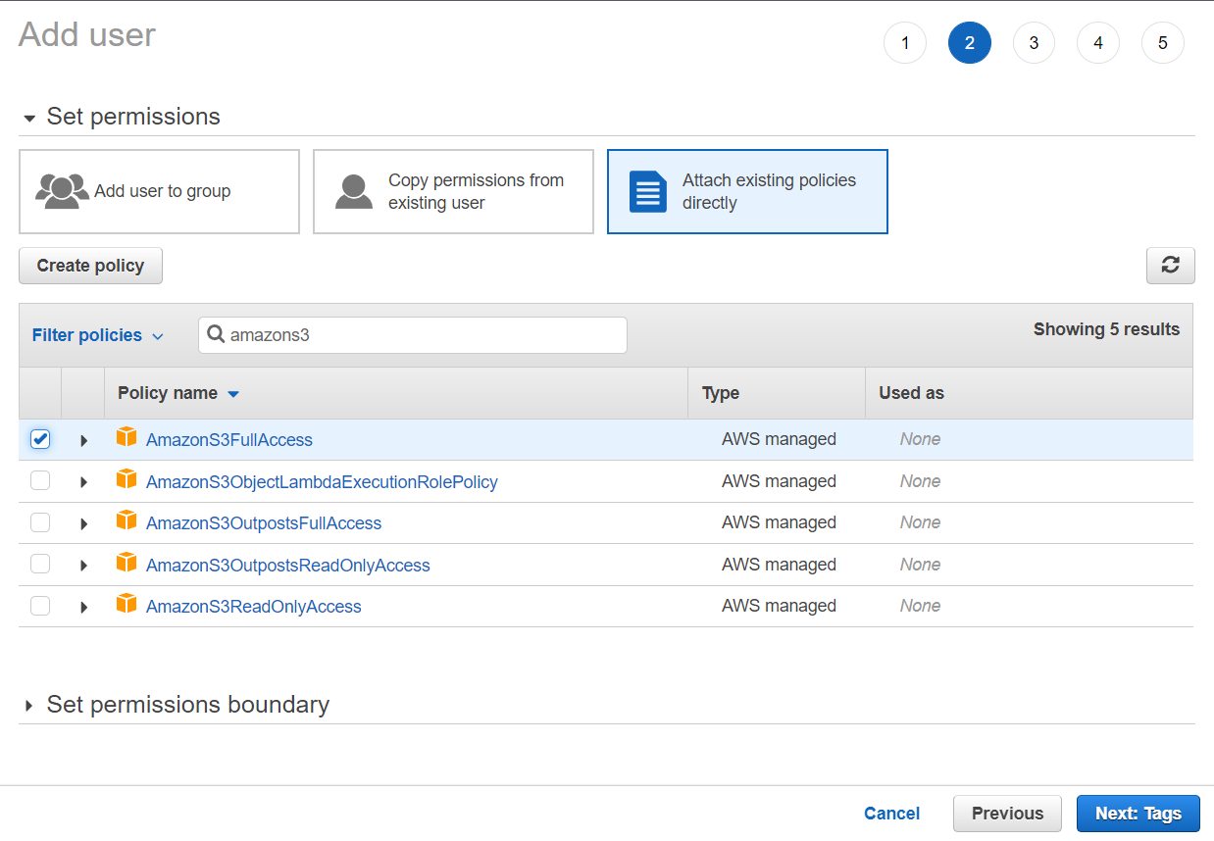
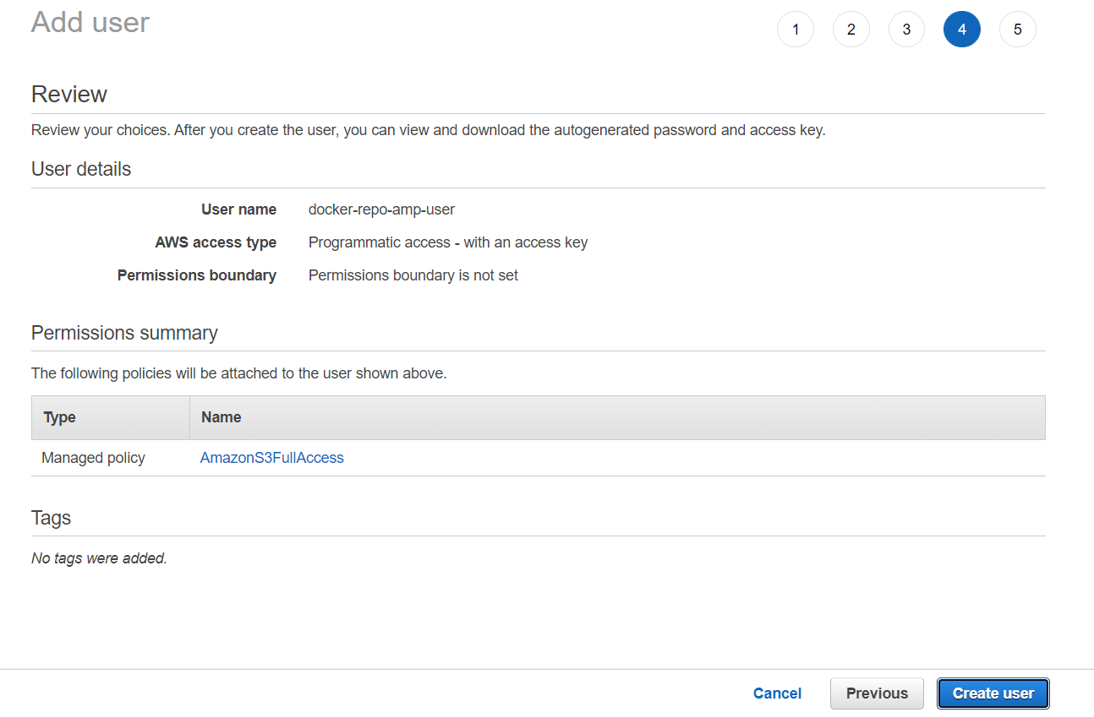
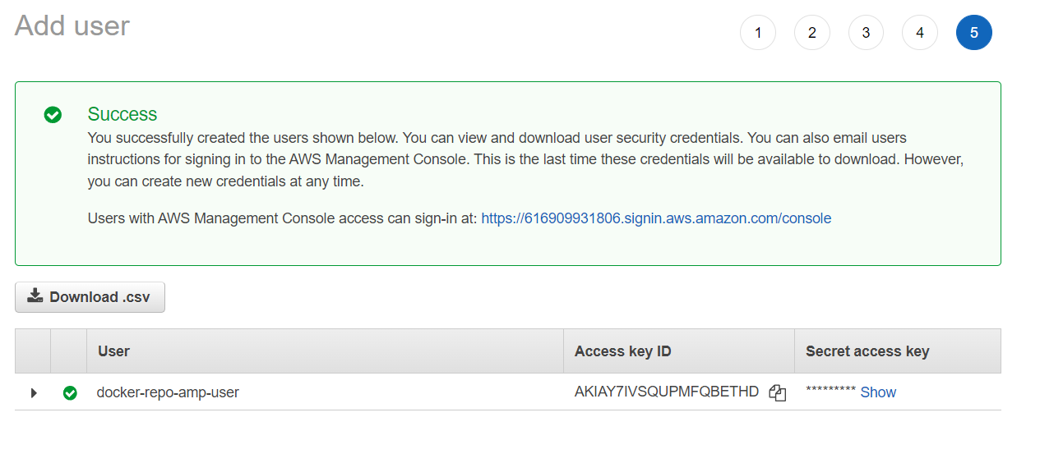

Copy the access key and secret access key to nexus
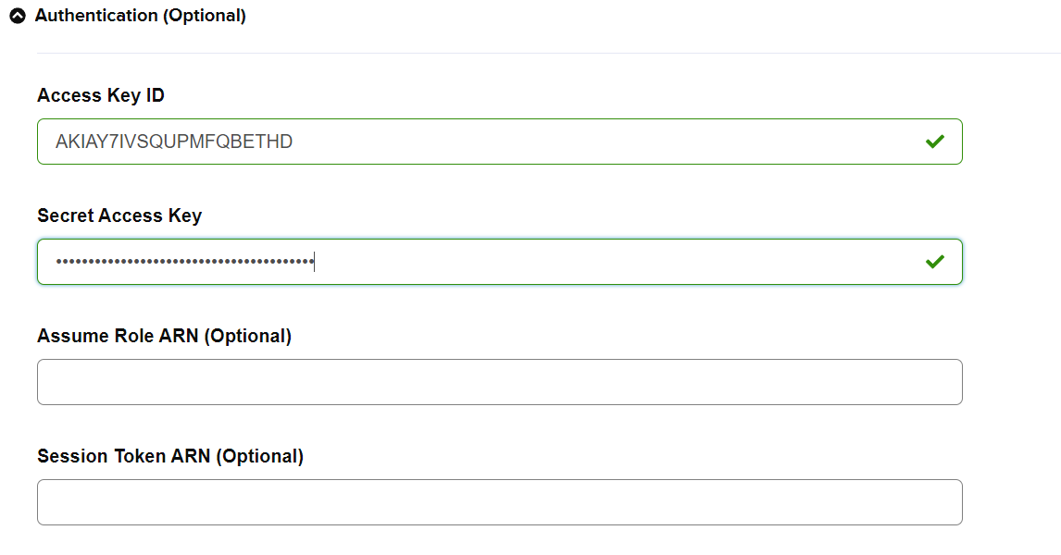
Then Click on Save.
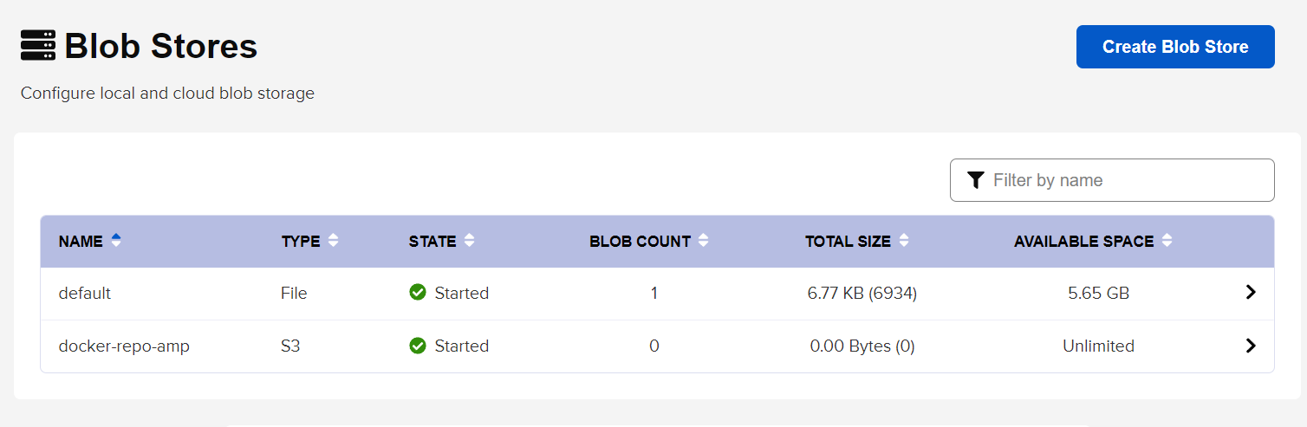
Go to repositories and click on create repository

Click on docker (hosted)
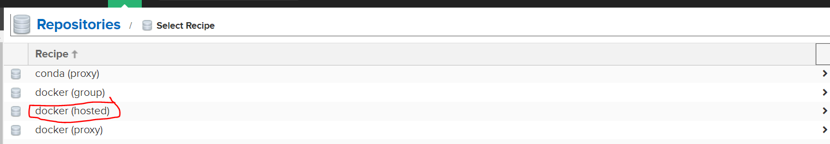

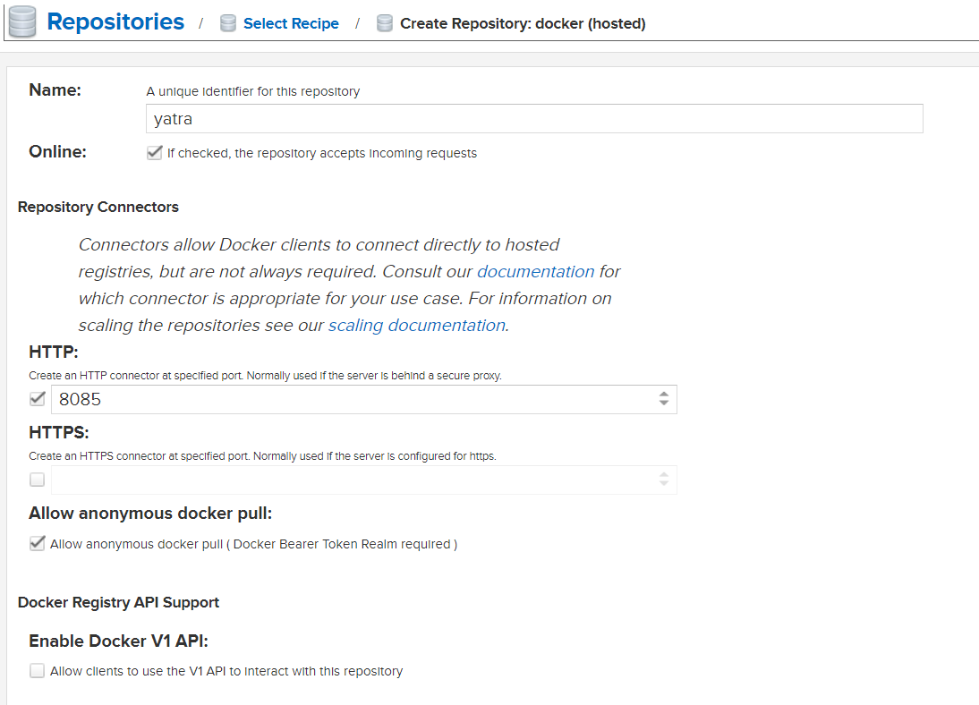
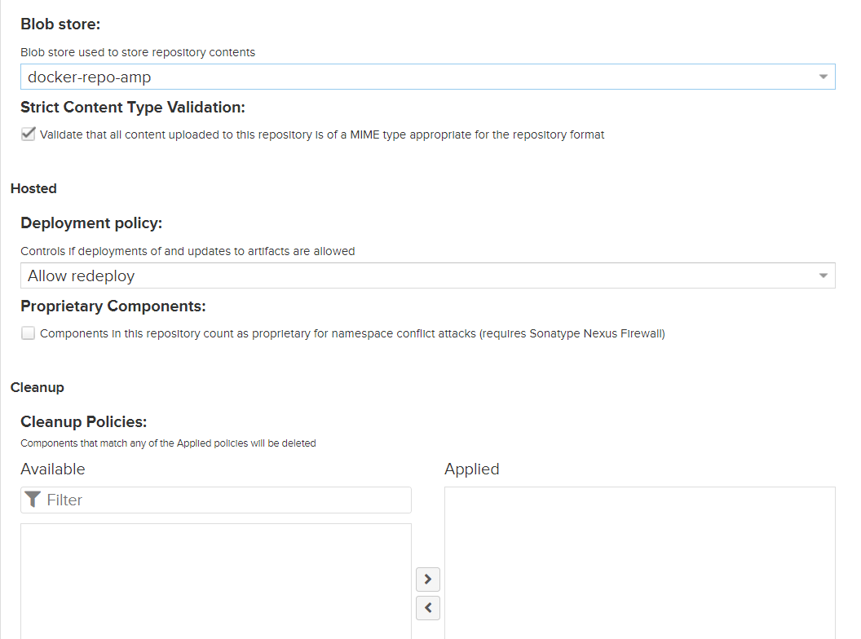
Then click on create repository

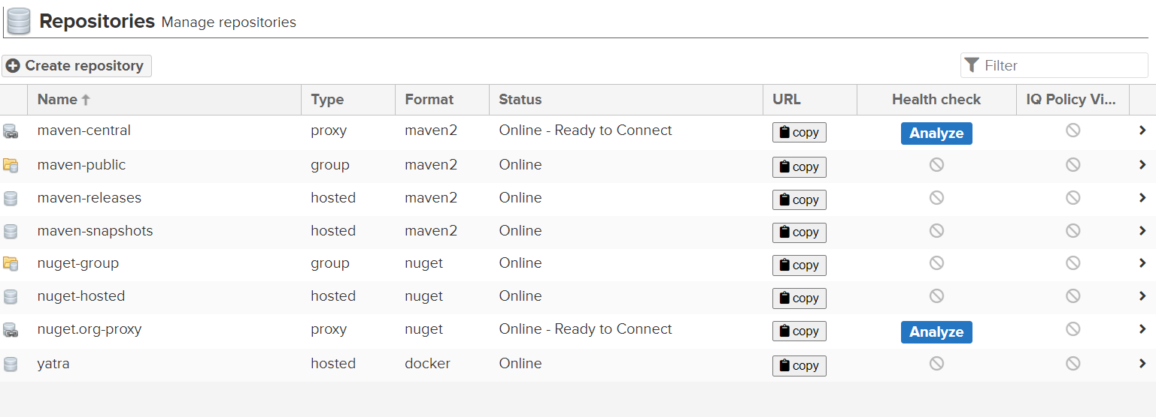
Click on realms
Activate
Local Authenticating realm
Local authorizing realm
Docker bearer token realm
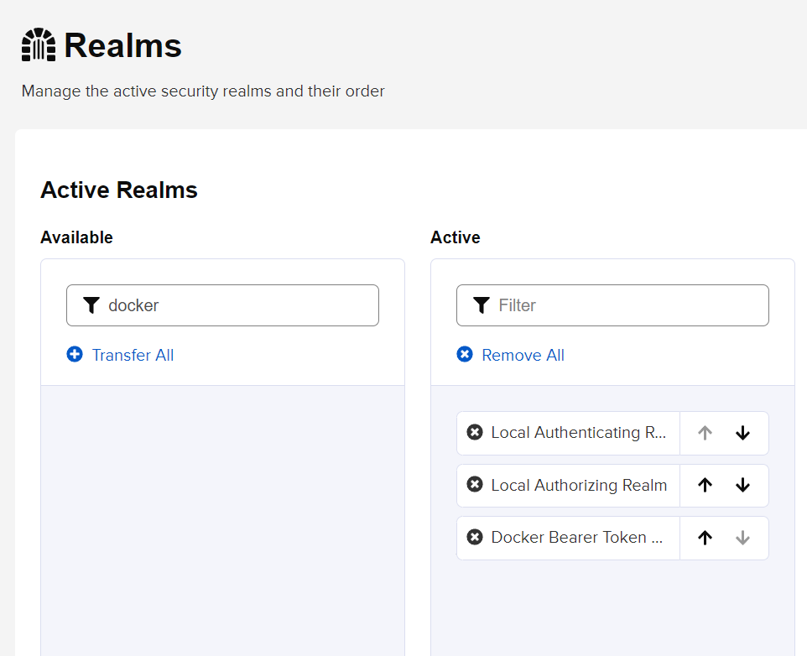
Click on save

Go to repositories and open yatra to get the details of yatra repository
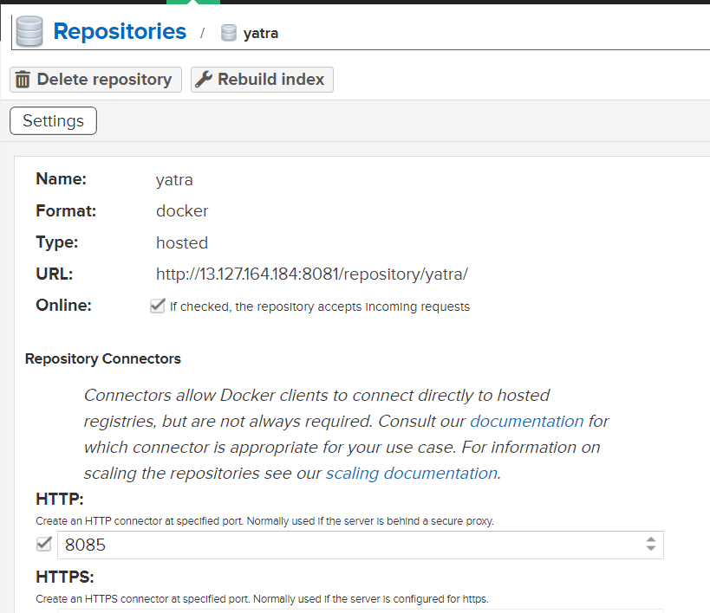
Edit the Jenkins file by adding the URL with the port number 8085.
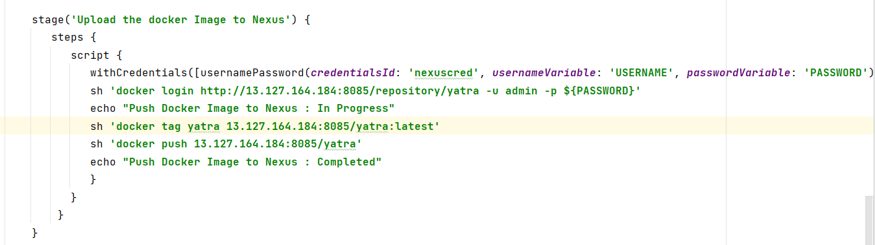
Push to git hub.
Git add --all
Git commit -m “ coderefactor”
Git push origin master

Go to jenkins console and add the nexus credential. Ensure the credential ID mentioned here and in Jenkins file are same.
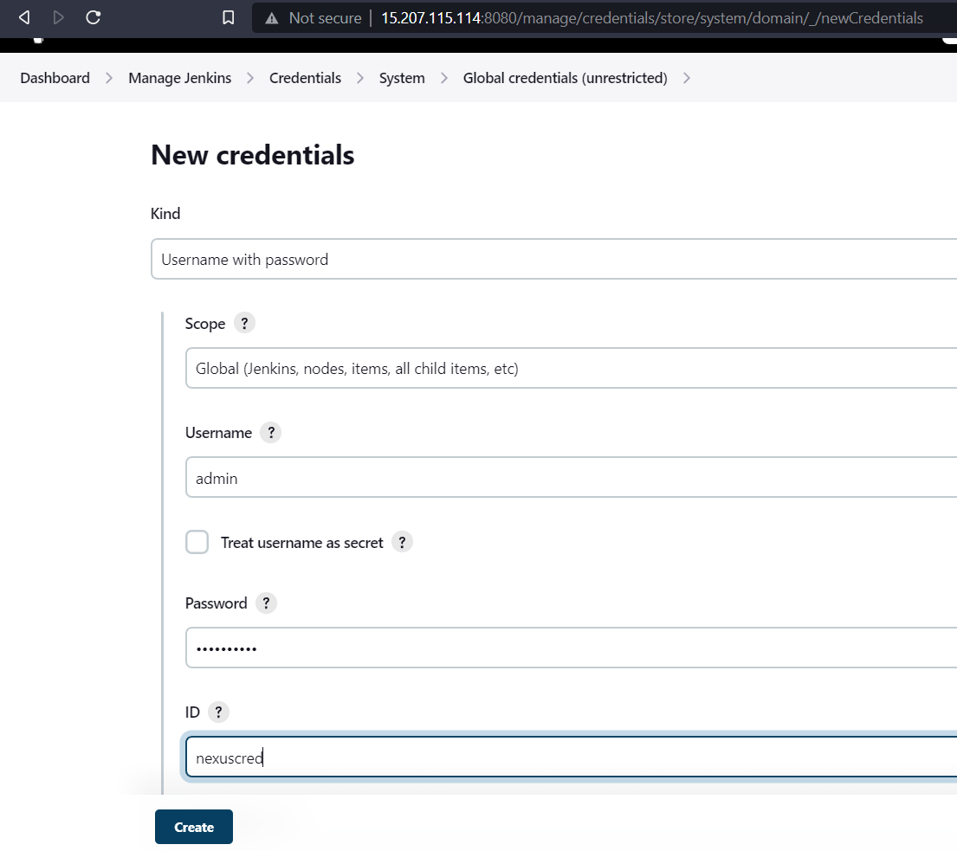
Click on create. And you can see the credentials.
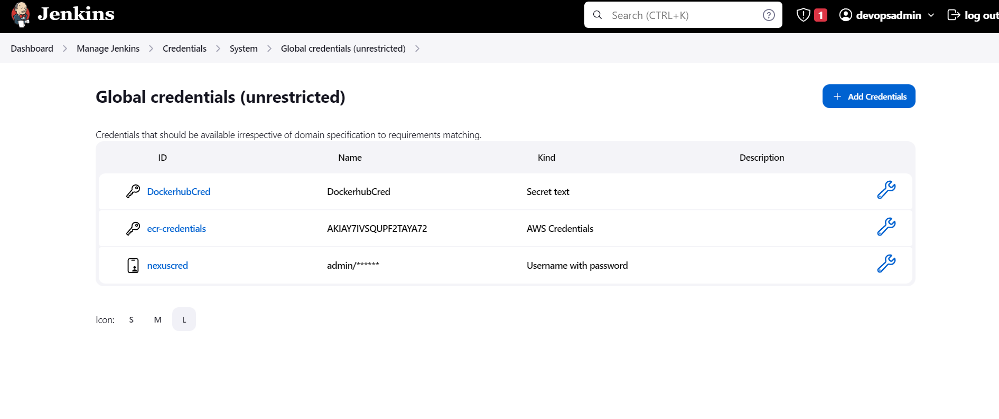

Go to Jenkins Master terminal
#Add the file daemon.json and enter the nexus ip.
cat > /etc/docker/daemon.json
{ "insecure-registries" : [ " 65.2.150.176:8085" ] }

Ctrl+d
Service docker stop
Service docker start
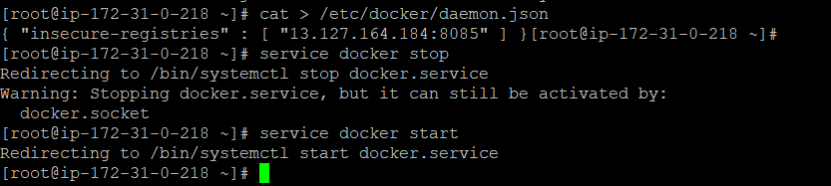

Go to Jenkins dash board and run the project yatra.

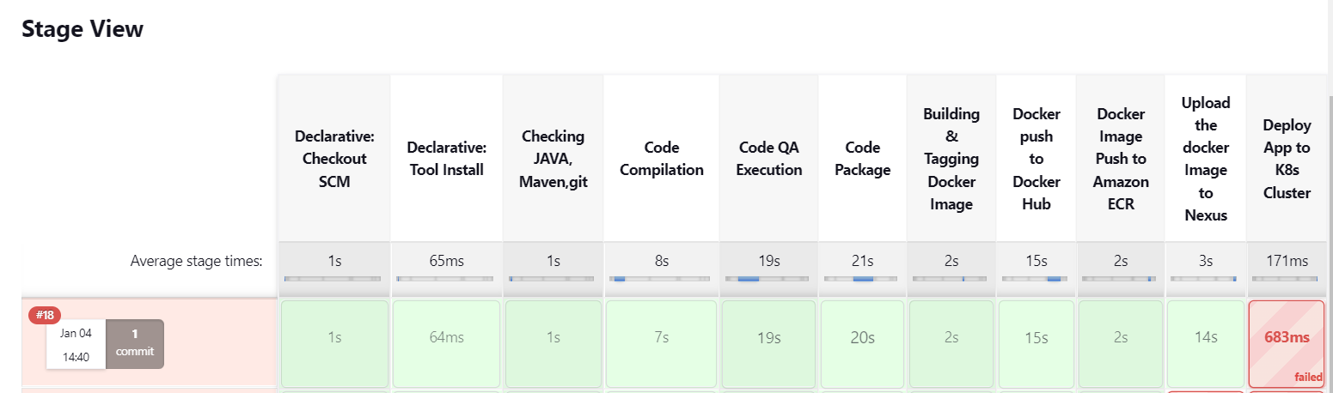

We can see the job was success until the image upload to nexus.

We can see the logs in console output.

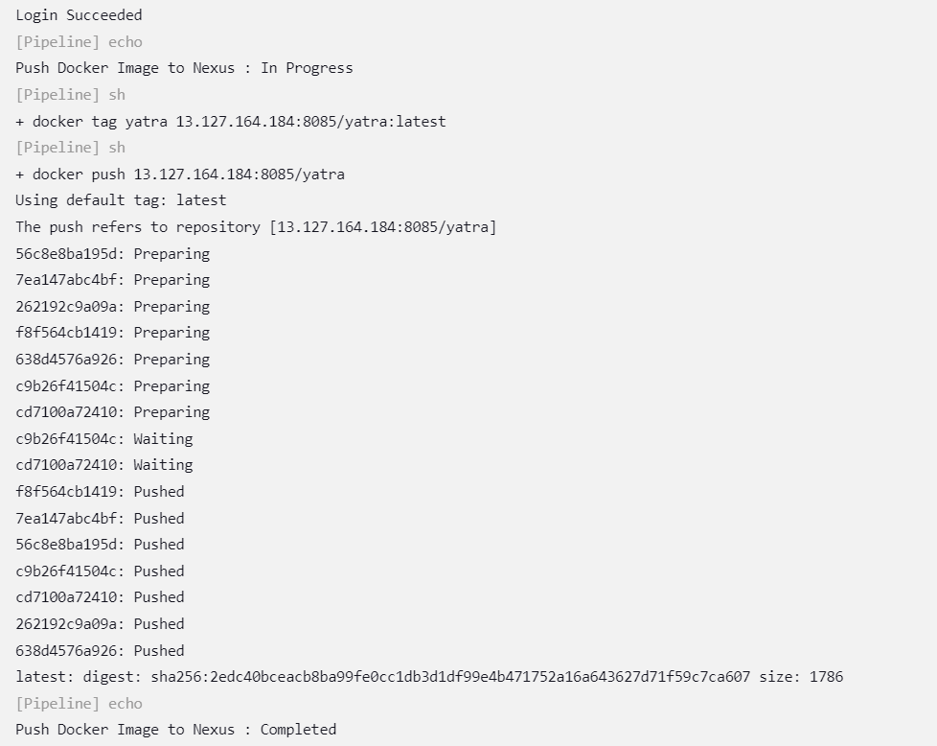

You can check the blob store in nexus repository. There we can see the size was changed.
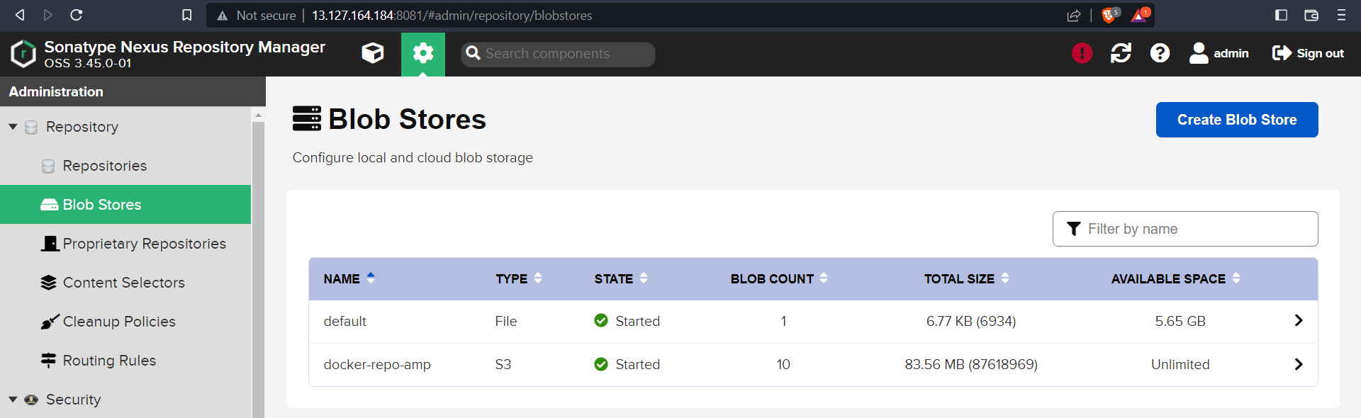

You can go to amazon s3 and view the files that we uploaded to nexus repository.
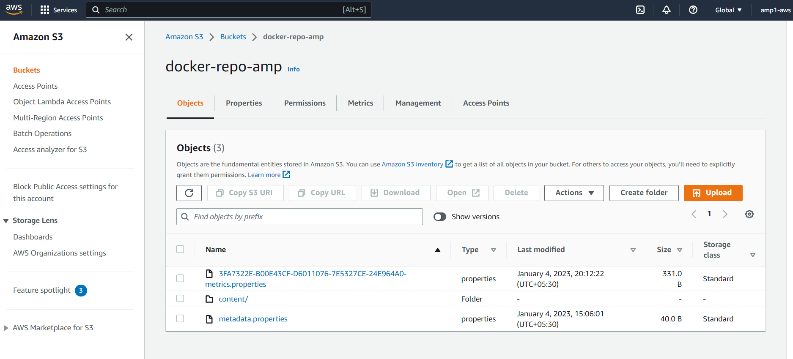
Click on the content and you can see the uploads.
